TIME SERIES ANALYSIS

**Definition:**

* A time series is a sequence of data points collected or recorded at successive, equally spaced intervals of time. These data points are typically ordered chronologically, allowing for the analysis of patterns, trends, and behaviours over time.
* In Time Series there is no relation between different attributes are observed but the change in same attribute is observed with change of time.
* It helps us understand how the value of the variable changes over time and is commonly used in various fields such as economics, finance, and environmental science for forecasting and analysis.

**Components of Time series:**

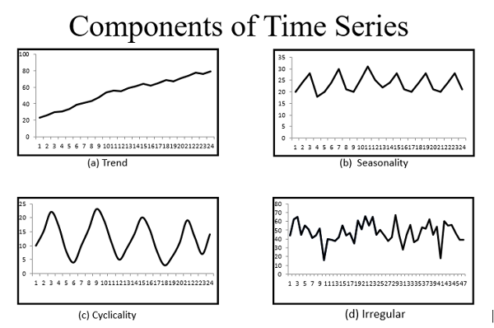

1. **Trend**: The long-term movement or direction of the data, showing whether it is increasing, decreasing, or stable over time.
2. **Seasonality**: Repeating patterns or fluctuations that occur at fixed intervals, often corresponding to seasons, months, days of the week, or other regular time periods.
3. **Cyclical Variation**: Fluctuations in the data that are not of a fixed period like seasonality but represent longer-term oscillations, often related to economic or business cycles.
4. **Irregularity/Randomness**: Unpredictable variations or noise in the data that cannot be attributed to the above components. This includes random fluctuations, outliers, and unpredictable events.

**Steps to create a Time series Model:**

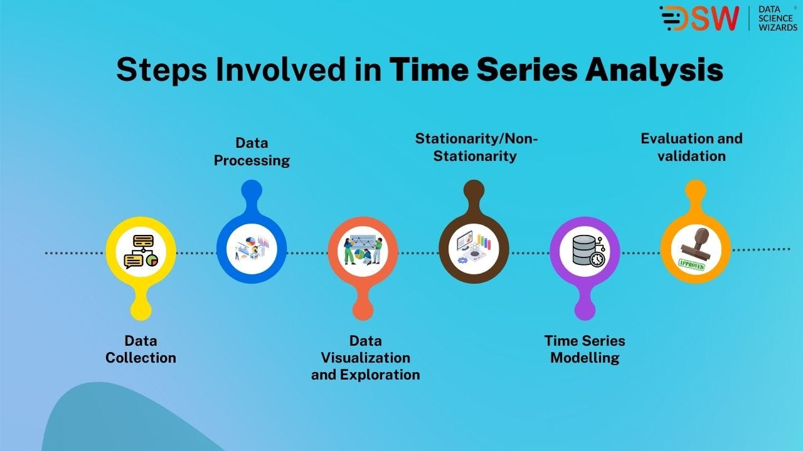

1. **Data Importing:** The initial step in time series analysis where data is fetched from external sources like files, databases, or APIs for further analysis.
2. **Data Cleaning:** This step involves preparing the time series data for analysis by addressing issues like missing values, errors, outliers, and ensuring consistency in time intervals.
3. **Stationary Check**: Determining if the time series exhibits stationary behavior, where statistical properties remain constant over time.
4. **Model Training**: Using historical data to train predictive models, such as ARIMA or machine learning algorithms, to learn patterns and relationships.
5. **Prediction**: Utilizing trained models to forecast future values of the time series based on historical data and learned patterns.
6. **Tuning**: Optimizing model parameters or settings to enhance prediction accuracy by adjusting hyperparameters or other relevant settings

**Models in Time Series:**

**Arima Model:**